RESOLUTION NO. 2017-3

A Resolution of the County Council of
Clay County, Indiana, Designating an Area Within
Clay County, Indiana as an Economic Revitalization Area
for the Purpose of a Real Property Tax Abatement

WHEREAS, a Petition for real property tax abatement has been filed with the County Council of Clay County, Indiana (hereinafter “County Council”) requesting that the property described therein be designated an Economic Revitalization Area for purposes of real property tax abatement; and

WHEREAS, KJKJ, LLC, and Process Development & Fabrication, Inc., (hereinafter the "petitioner,") have submitted a Statement of Benefits and provided all information and documentation necessary for the County Council to make an informed decision, said information including a description of the real property which is more particularly described in Exhibit A.

WHEREAS, petitioner has represented and presented evidence that in connection with this Project it currently has an existing 164 full-time jobs with an annual payroll of $7,215,000 (approximately). Completion of this project will permit petitioner to maintain the existing full-time jobs and will create approximately 5 new permanent full-time, salaried jobs with a total annual payroll of approximately $114,000. Petitioner has further represented and presented evidence that the cost of this project will be approximately $1,800,000 for real property improvements.

WHEREAS, the County Council is authorized under the provisions of I.C. 6-1.1-12.1-1 et. seq. to designate areas of the County as economic revitalization areas for the purpose of tax abatement; and

WHEREAS, the County Council has considered the petition and Statement of Benefits and has conducted a complete and proper investigation of the subject property and neighborhood to determine that the area qualifies as an economic revitalization area under Indiana statutes; and

WHEREAS, the County Council has found the subject property to be an area where facilities that are technologically, economically, or energy obsolete are located and where the
obsolescence may lead to a decline in employment and tax revenues and has become undesirable for or impossible of normal development and occupancy because of a lack of development, cessation of growth, deterioration of improvements, character of occupancy, age, obsolescence, substandard buildings and other factors which prevent normal development or use;

NOW, THEREFORE, IT IS FOUND, DETERMINED AND RESOLVED by the County Council of Clay County, Indiana, that:

1. The petitioner's estimate of the value of the redevelopment and rehabilitation and the project to be constructed on the subject real property is reasonable for projects of that nature in order to maintain, expand, update and improve opportunities in Clay County for manufacturing.

2. The petitioner's estimate of the number of individuals who will be employed and retained, and the benefit thereby, can reasonably be expected to result from the project and the redevelopment and rehabilitation.

3. The petitioner's estimate of the annual salaries or wages of the individuals who will be employed and retained, and the benefit thereby, can reasonably be expected to result from the project and the redevelopment and rehabilitation.

4. That the other benefits about which information has been requested can be expected to result from the project and the redevelopment and rehabilitation.

5. The totality of the benefits of the proposed redevelopment and rehabilitation can reasonably be expected to result from the project and are sufficient to justify a ten year real property tax deduction from assessed valuation under Indiana statutes, in accord with the attached Deduction Schedule and each such deduction should be, and they are hereby, allowed in accord with the attached Abatement Schedule.

6. Based upon: (1) the Petitioner’s total investment in real and personal property; (2) the number of new full-time equivalent jobs created or retained; (3) the average wage of the new employees compared to the State minimum wage; and (4) the infrastructure requirements for Petitioner’s investment and the totality of the benefits of the proposed project and installation of the new manufacturing equipment are sufficient to justify personal property tax abatement over a _________ year deduction period, in accord with the attached Deduction Schedule and each such deduction should be, and they are hereby, allowed in accord with the attached Abatement Schedule.

7. That the petition for designating the subject property as an economic revitalization area for the purposes of ____ year real property tax abatement and the Statement of Benefits copies of which were submitted with the petitions are hereby approved and the Real Estate described hereinabove is hereby designated as an Economic Revitalization Area pursuant to I.C. 6-1.1-12.1-1 et. seq., and petitioner is entitled to the ____ year real property tax abatement pursuant to the following _____ year abatement deduction schedule which the County Council hereby establishes, prescribes, and adopts: SEE EXHIBIT B ATTACHED HERETO, for the proposed redevelopment and rehabilitation.

8. That notice hereof should be published according to law stating the adoption and substance hereof, that a copy of the description of the affected area is available for inspection in the County Assessor's Office and stating a date on which the County Council will hear and receive remonstrances and objections and take final action, all as required by law.

9. That this Resolution is supplementary to and in addition to any prior resolutions.

10. That this abatement is subject to the terms and provisions of the Abatement Calculation Agreement entered by and between the County Council of Clay County, Indiana, and Petitioner pursuant to I.C. 6-1.1-12.1-2(i).

11. Pursuant to I.C. 6-1.1-12.1-14, the County Council of Clay County, Indiana, has, pursuant to Resolution 6-2008, established an Abatement Fee, Petitioner has been advised of said fee and agreed to the imposition of the Abatement Fee and incorporation of that fee in the initial Resolution approving the Abatement. Now, therefore, the County Council of Clay County, Indiana, incorporates herein the provisions of I.C. 6-1.1-12.1-14 and declares that the percentage to be applied by the County Auditor for purposes of Step Two of I.C. 6-1.1-12.1-14(c) is 5%.

Passed in Open Council this ____ day of _______________________, 2017.

CLAY COUNTY COUNCIL

_________________________________ __________________________________
Dave Amerman Jacqueline Mitchell

_________________________________ __________________________________
Toni Carter Larry J. Moss

_________________________________ __________________________________
Jason Britton John Nicoson

_________________________________
Patricia Heffner

I prepared the foregoing instrument and I affirm, under the penalties for perjury, that I have taken reasonable care to redact each social security number in this document, unless required by law.

________________________________________
Louis F. Britton
COX, ZWERNER, GAMBILL & SULLIVAN, LLP
511 Wabash Avenue
Terre Haute, IN 47807
Phone: (812) 232-6003

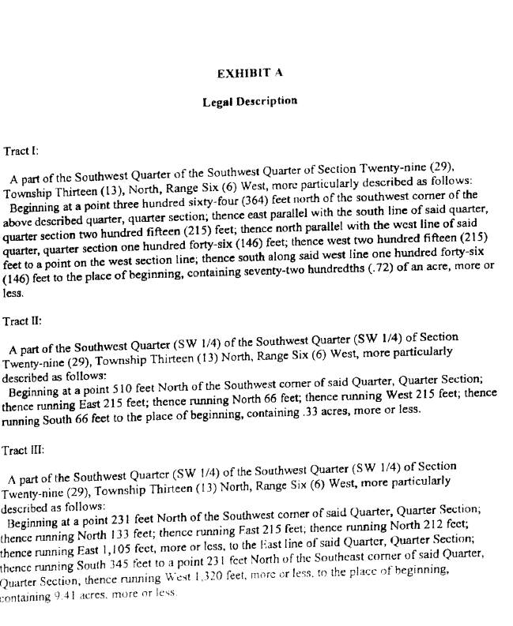

EXHIBIT B

DEDUCTION SCHEDULE

10 YEAR REAL PROPERTY

YEAR OF DEDUCTION | PERCENTAGE
1ST | 100%
2ND | 95%
3RD | 80%
4TH | 65%
5TH | 50%
6TH | 40%
7TH | 30%
8TH | 20%
9TH | 10%
10TH | 5%

